STRUCTURE TO STORE AND RETRIEVE INFORMATION

ITP Assignment- 2

Kriti Shukla (IEC2021067) Manya Agrawal (IEC2021068) Aswitha Sai (IEC2021069) Naman Suhane (IEC2021070) Department of Electronics and Communication Engineering Indian Institute of Information Technology, Allahabad

***Abstract –* In this report, we have used structures to store the information of different engine parts i.e. serial number, year of manufacturing, material used, quantity of the engine parts and to retrieve the information of engine parts between BB1 to CC6 .**

***KEYWORDS* – int, struct, char, for, if, continue**.

**I. INTRODUCTION**

Structure is a user-defined datatype in C language which allows us to combine data of different data types together. It is similar to an array but the only difference is that the array holds data of similar type. Structure helps to construct a complex data type which is more meaningful.

To solve the problem, we have defined a structure data type engine to store different types of information about the engine parts and retrieve the information of some specified parts.

We have used a for loop, if statement and continue statement in the code.

**II. GENERALIZATION OF THE TECHNIQUE**

* A structure is a user -defined data type in C/C++.A structure creates a data type that can be used to group items of possibly different types into a single type.
* ‘Struct’ keyword is used to creates the engine structure as:

struct engine

{

char serial[3]; int quantity; int yom;

char mat[40];

}car[10];

* Get the number of engine parts whose details are to be stored. Here we are taking 5 parts for simplicity.
* Create a variable of engine structure

To access the information. Here it is taken as ‘engine’.

* Get the data of n engine parts and store it in engine’s field with the help of dot(.) operator

**III.** **ALGORITHM**

1) We have created a structure data type for the engine to store information of different types corresponding to different parts of the engine.

2)We have initialized char data type for storing the serial no. and kind material used

3) We take no parts of the engine from the user using printf and scanf statements.

4) We run the first ‘for’ loop to get information like "serial no","quantity", "Year of manufacturing", and "material used " corresponding to each part from the user.

5)Now we run one more ‘for’ loop to retrieve information of the parts with serial numbers between BB1 and CC6.

6)"Continue" statement helps us to execute the next iteration of the loop instead of coming out of the loop if the given condition fails for something.

Here we used an "if" condition for char A and then continue and for char more then C and continue to get information of parts only between BB1 and CC6.

7)At last we use a printf statement "info about the parts between BB1 and CC6 " to

print the information corresponding to that part.

**IV. OUTPUT**

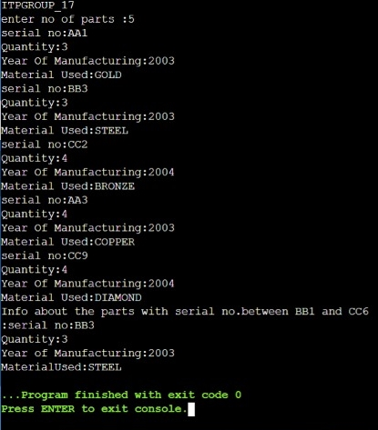

**V. TIME OF EXECUTION**

Case1- 62.568ms

Case 2- 65.683ms

Case 3- 67.536ms

Average time of execution: 62.568+65.683+67.536 = 65.262

3

**VI. CONCLUSION**

We can conclude that structure is used to represent information about something more complicated than a single number, character, or boolean can do as it is a composite data type (or record) declaration that defines a physically grouped list of variables under one name in a block of memory .

**VII. ACKNOWLEDGMENT**

We would like to express our special thanks to Professor Dr Mohammed Javed and teaching assistant Md Miraz who gave us the golden opportunity to do this wonderful report which also helped us in doing a lot of research and thanks to them for their able guidance and support in completing our report .

**VIII. REFERENCES**

* Let us C by Yashavant Kanetkar.
* Code blocks, Online compiler for compilation and execution .

**IX. APPENDIX**

